Configuracion de tipo de datos en: Base de Datos, Java y Hibernate
Informacion oficial:
https://docs.jboss.org/hibernate/orm/5.4/userguide/html_single/Hibernate_User_Guide.html#basic
Hibernate ORM 5.4.12.Final User Guide
Vlad Mihalcea, Steve Ebersole, Andrea Boriero, Gunnar Morling, Gail Badner, Chris Cranford, Emmanuel Bernard, Sanne Grinovero, Brett Meyer, Hardy Ferentschik, Gavin King, Christian Bauer, Max Rydahl Andersen, Karel Maesen, Radim Vansa, Louis Jacomet

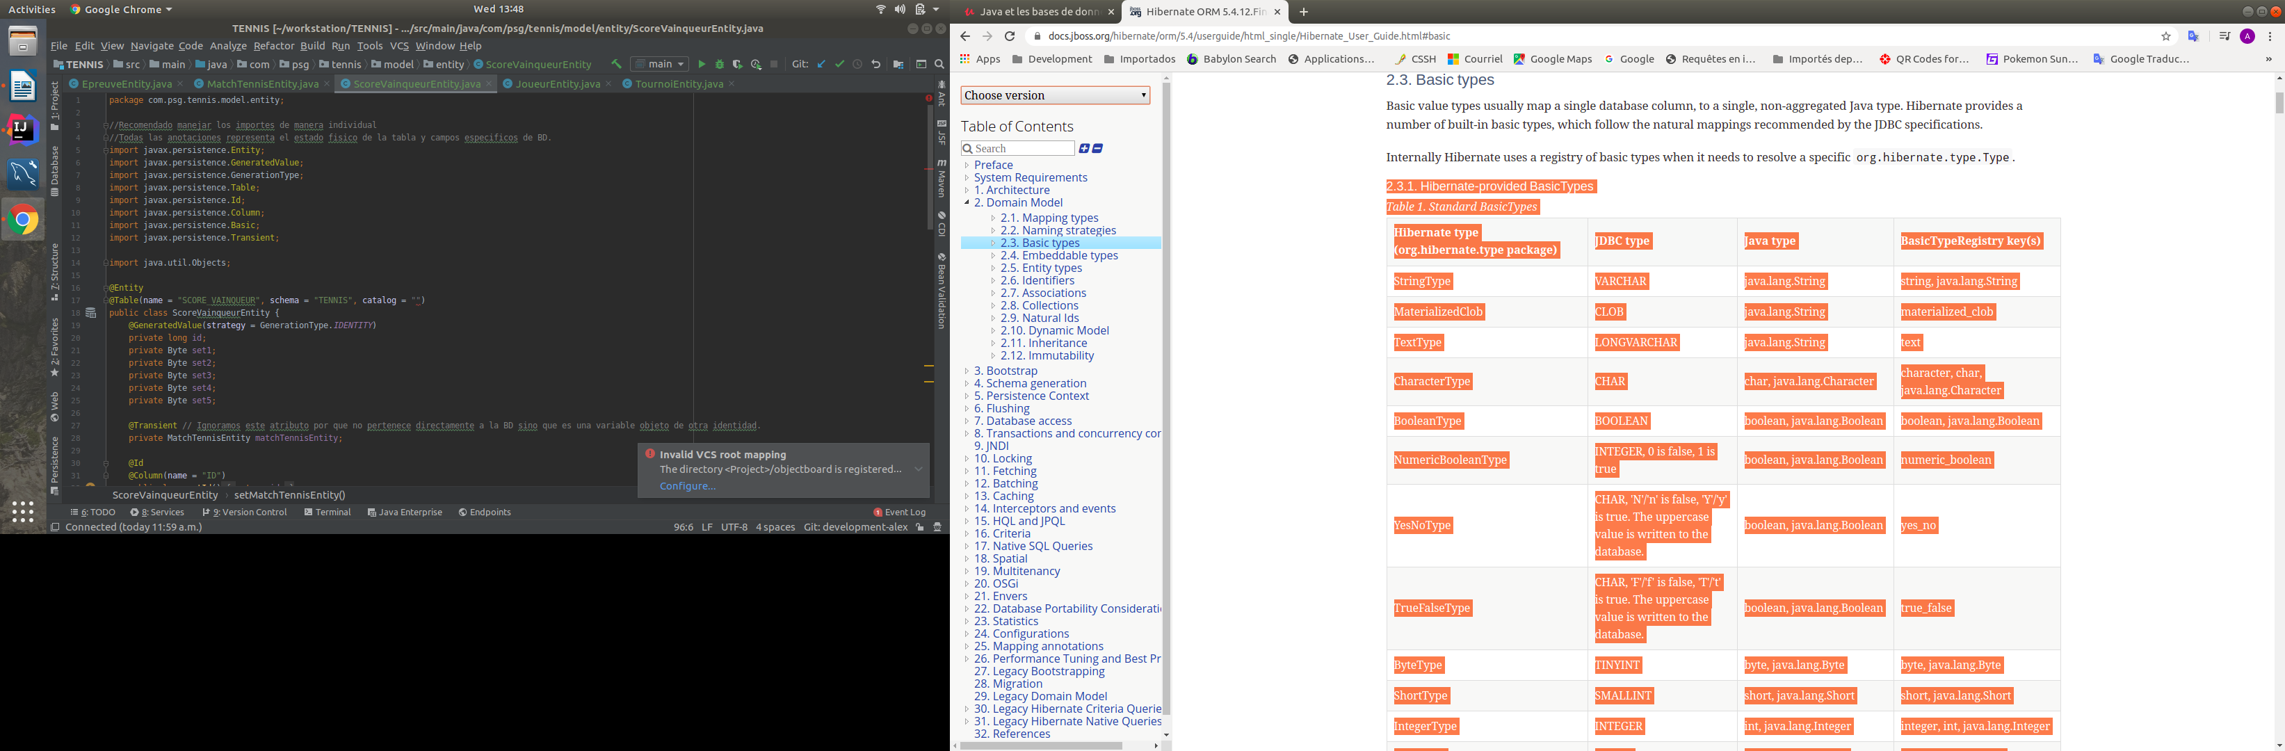

2.3.1. Hibernate-provided BasicTypes
El anotado de configuracion para las classes Entity
@Type(type=””)
Table 1. Standard BasicTypes
LADO (TEORICAMENTE) BASE DE DATO JAVA (Entidades) Tipos q nosInteresan
Hibernate type (org.hibernate.type package) | JDBC type | Java type | BasicTypeRegistry key(s)
StringType | VARCHAR | java.lang.String | string, java.lang.String
MaterializedClob | CLOB | java.lang.String | materialized_clob
TextType | LONGVARCHAR | java.lang.String | text
CharacterType | CHAR | char, java.lang.Character | character, char, java.lang.Character
BooleanType | BOOLEAN | boolean, java.lang.Boolean | boolean, java.lang.Boolean
NumericBooleanType | INTEGER, 0 is false, 1 is true | boolean, java.lang.Boolean | numeric_boolean
YesNoType | CHAR, 'N'/'n' is false, 'Y'/'y' is true. The uppercase value is written to the database. | boolean, java.lang.Boolean | yes_no
TrueFalseType | CHAR, 'F'/'f' is false, 'T'/'t' is true. The uppercase value is written to the database. | boolean, java.lang.Boolean | true_false
ByteType | TINYINT | byte, java.lang.Byte | byte, java.lang.Byte
ShortType | SMALLINT | short, java.lang.Short | short, java.lang.Short
IntegerType | INTEGER | int, java.lang.Integer | integer, int, java.lang.Integer
LongType | BIGINT | long, java.lang.Long | long, java.lang.Long
FloatType | FLOAT | float, java.lang.Float | float, java.lang.Float
DoubleType | DOUBLE | double, java.lang.Double | double, java.lang.Double
BigIntegerType | NUMERIC | java.math.BigInteger | big_integer, java.math.BigInteger
BigDecimalType | NUMERIC | java.math.BigDecimal | big_decimal, java.math.bigDecimal
TimestampType | TIMESTAMP | java.util.Date | timestamp, java.sql.Timestamp, java.util.Date
DbTimestampType | TIMESTAMP | java.util.Date | dbtimestamp
TimeType | TIME | java.util.Date | time, java.sql.Time
DateType | DATE | java.util.Date | date, java.sql.Date
CalendarType | TIMESTAMP | java.util.Calendar | calendar, java.util.Calendar, java.util.GregorianCalendar
CalendarDateType | DATE | java.util.Calendar | calendar_date
CalendarTimeType | TIME | java.util.Calendar | calendar_time
CurrencyType | VARCHAR | java.util.Currency | currency, java.util.Currency
LocaleType | VARCHAR | java.util.Locale | locale, java.util.Locale
TimeZoneType | VARCHAR, using the TimeZone ID | java.util.TimeZone | timezone, java.util.TimeZone
UrlType | VARCHAR | java.net.URL | url, java.net.URL
ClassType | VARCHAR (class FQN) | java.lang.Class | class, java.lang.Class
BlobType | BLOB | java.sql.Blob | blob, java.sql.Blob
ClobType | CLOB | java.sql.Clob | clob, java.sql.Clob
BinaryType | VARBINARY | byte[] | binary, byte[]
MaterializedBlobType | BLOB | byte[] | materialized_blob
ImageType | LONGVARBINARY | byte[] | image
WrapperBinaryType | VARBINARY | java.lang.Byte[] | wrapper-binary, Byte[], java.lang.Byte[]
CharArrayType | VARCHAR | char[] | characters, char[]
CharacterArrayType | VARCHAR | java.lang.Character[] | wrapper-characters, Character[], java.lang.Character[]
UUIDBinaryType | BINARY | java.util.UUID | uuid-binary, java.util.UUID
UUIDCharType | CHAR, can also read VARCHAR | java.util.UUID | uuid-char
PostgresUUIDType | PostgreSQL UUID, through Types#OTHER, which complies to the PostgreSQL JDBC driver definition | java.util.UUID | pg-uuid
SerializableType | VARBINARY | implementors of java.lang.Serializable | Unlike the other value types, multiple instances of this type are registered. It is registered once under java.io.Serializable, and registered under the specific java.io.Serializable implementation class names.
StringNVarcharType | NVARCHAR | java.lang.String | nstring
NTextType | LONGNVARCHAR | java.lang.String | ntext
NClobType | NCLOB | java.sql.NClob | nclob, java.sql.NClob
MaterializedNClobType | NCLOB | java.lang.String | materialized_nclob
PrimitiveCharacterArrayNClobType | NCHAR | char[] | N/A
CharacterNCharType | NCHAR | java.lang.Character | ncharacter
CharacterArrayNClobType | NCLOB | java.lang.Character[] | N/A
RowVersionType | VARBINARY | byte[] | row_version
ObjectType | VARCHAR | implementors of java.lang.Serializable | object, java.lang.Object

Ejemplo:

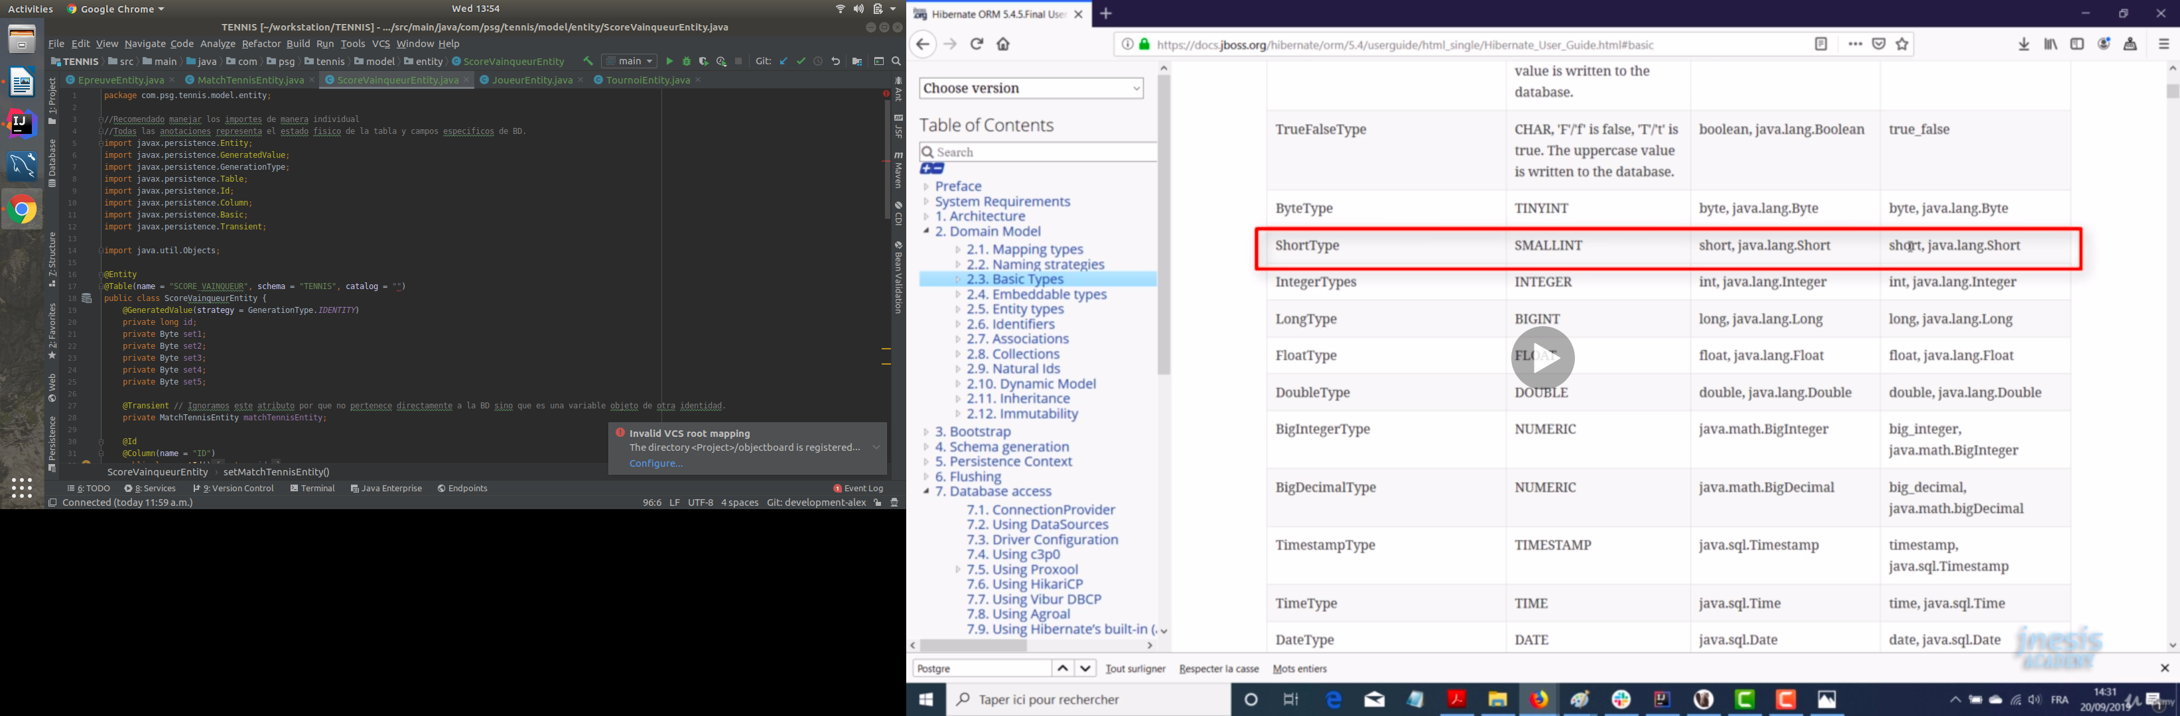
Si nos interesa un shor debemos especificar un SMALLINT en Base de dato y del lado de Java en la clase Identidad un short o un Short.

Lado Entidad -> private short annee; hay casos donde debemos ayudar Hibernate con la anotacion sobre todo con los de tipo boolean: @Type(type=”short”)

1) En registro de archivo:

INFO: HHH10001501: Connection obtained from JdbcConnectionAccess [org.hibernate.engine.jdbc.env.internal.JdbcEnvironmentInitiator$ConnectionProviderJdbcConnectionAccess@7acfb656] for (non-JTA) DDL execution was not in auto-commit mode; the Connection 'local transaction' will be committed and the Connection will be set into auto-commit mode.
Mar. 11, 2020 8:25:51 P.M. org.hibernate.engine.transaction.jta.platform.internal.JtaPlatformInitiator initiateService
INFO: HHH000490: Using JtaPlatform implementation: [org.hibernate.engine.transaction.jta.platform.internal.NoJtaPlatform]
Create to language

Process finished with exit code 0

nos salta:

Session.flush();

2) TransactionRequiredException: no transaction is in progress

INFO: HHH000490: Using JtaPlatform implementation: [org.hibernate.engine.transaction.jta.platform.internal.NoJtaPlatform]
javax.persistence.TransactionRequiredException: no transaction is in progress
at org.hibernate.internal.SessionImpl.checkTransactionNeeded(SessionImpl.java:3586)
at org.hibernate.internal.SessionImpl.doFlush(SessionImpl.java:1447)
at org.hibernate.internal.SessionImpl.flush(SessionImpl.java:1443)
at com.psg.objectboard.model.repository.LanguageRepositoryImpl.create(LanguageRepositoryImpl.java:18)
at com.psg.objectboard.model.service.LanguageService.createLanguage(LanguageService.java:33)
at com.psg.objectboard.controller.LanguageController.createLanguage(LanguageController.java:41)
at com.psg.objectboard.consoleview.main.main(main.java:13)
LanguageDto no funciona

Process finished with exit code 0

Razones: con Session.flush();
El objeto se encuentra en seccion Persistencia.
ha pasado de estado de Transient a Persistent confiado a Hibernate,
pero muchos obj pasaremos a seccion, para insertar debemos indicar a hibernar para que se ejecute en insert.

Para ello Hibernete nos exige de este se debe realizar en una transaccion.

3)IllegalStateException: Transaction not successfully started
The name lenguage modify is called = Venezuela
java.lang.IllegalStateException: Transaction not successfully started
at org.hibernate.engine.transaction.internal.TransactionImpl.commit(TransactionImpl.java:98)
at com.psg.objectboard.model.service.LanguageService.reName(LanguageService.java:216)
at com.psg.objectboard.controller.LanguageController.modifyLanguage(LanguageController.java:64)
at com.psg.objectboard.consoleview.main.main(main.java:30)
LanguageDto no funciona

Causa: olvidado transaction.begin();

4) IllegalArgumentException: Removing a detached instance com.psg.objectboard.model.entity.LanguageEntity#1

java.lang.IllegalArgumentException: Removing a detached instance com.psg.objectboard.model.entity.LanguageEntity#1
at org.hibernate.event.internal.DefaultDeleteEventListener.disallowDeletionOfDetached(DefaultDeleteEventListener.java:195)
at org.hibernate.event.internal.DefaultDeleteEventListener.performDetachedEntityDeletionCheck(DefaultDeleteEventListener.java:183)
at org.hibernate.event.internal.DefaultDeleteEventListener.onDelete(DefaultDeleteEventListener.java:105)
at org.hibernate.event.internal.DefaultDeleteEventListener.onDelete(DefaultDeleteEventListener.java:72)
at org.hibernate.internal.SessionImpl.fireDelete(SessionImpl.java:1014)
at org.hibernate.internal.SessionImpl.delete(SessionImpl.java:950)
at org.hibernate.internal.SessionImpl.remove(SessionImpl.java:3472)
at com.psg.objectboard.model.service.LanguageService.deleteLanguage(LanguageService.java:175)
at com.psg.objectboard.controller.LanguageController.deleteLanguage(LanguageController.java:85)
at com.psg.objectboard.consoleview.main.main(main.java:30)
Borrar Service no funciona

Causa: se debe cargar Find by primary key.
* Search for an entity of the specified class and primary key.
* If the entity instance is contained in the persistence context,
* it is returned from there.

ERRORES EN RELACION A TABLAS ENTITY

5) Org.hibernate.MappingException: Could not determine type for:com.psg.projectobject.language, at table for columns.

Causa: Hibernate Intenta mapear automaticamente campos entre la clase identidad y la tabla de bd
en este particular es un campo de tipo clave a otra tabla, para ingnorar a un punto de no interesar,
podemos utilizar la anotacion @Transient. para excluir en el procesos de mapping de hibernate.

6) org.hibernate....SchemaManagementException.
java.lang.ExceptionInInitializerError
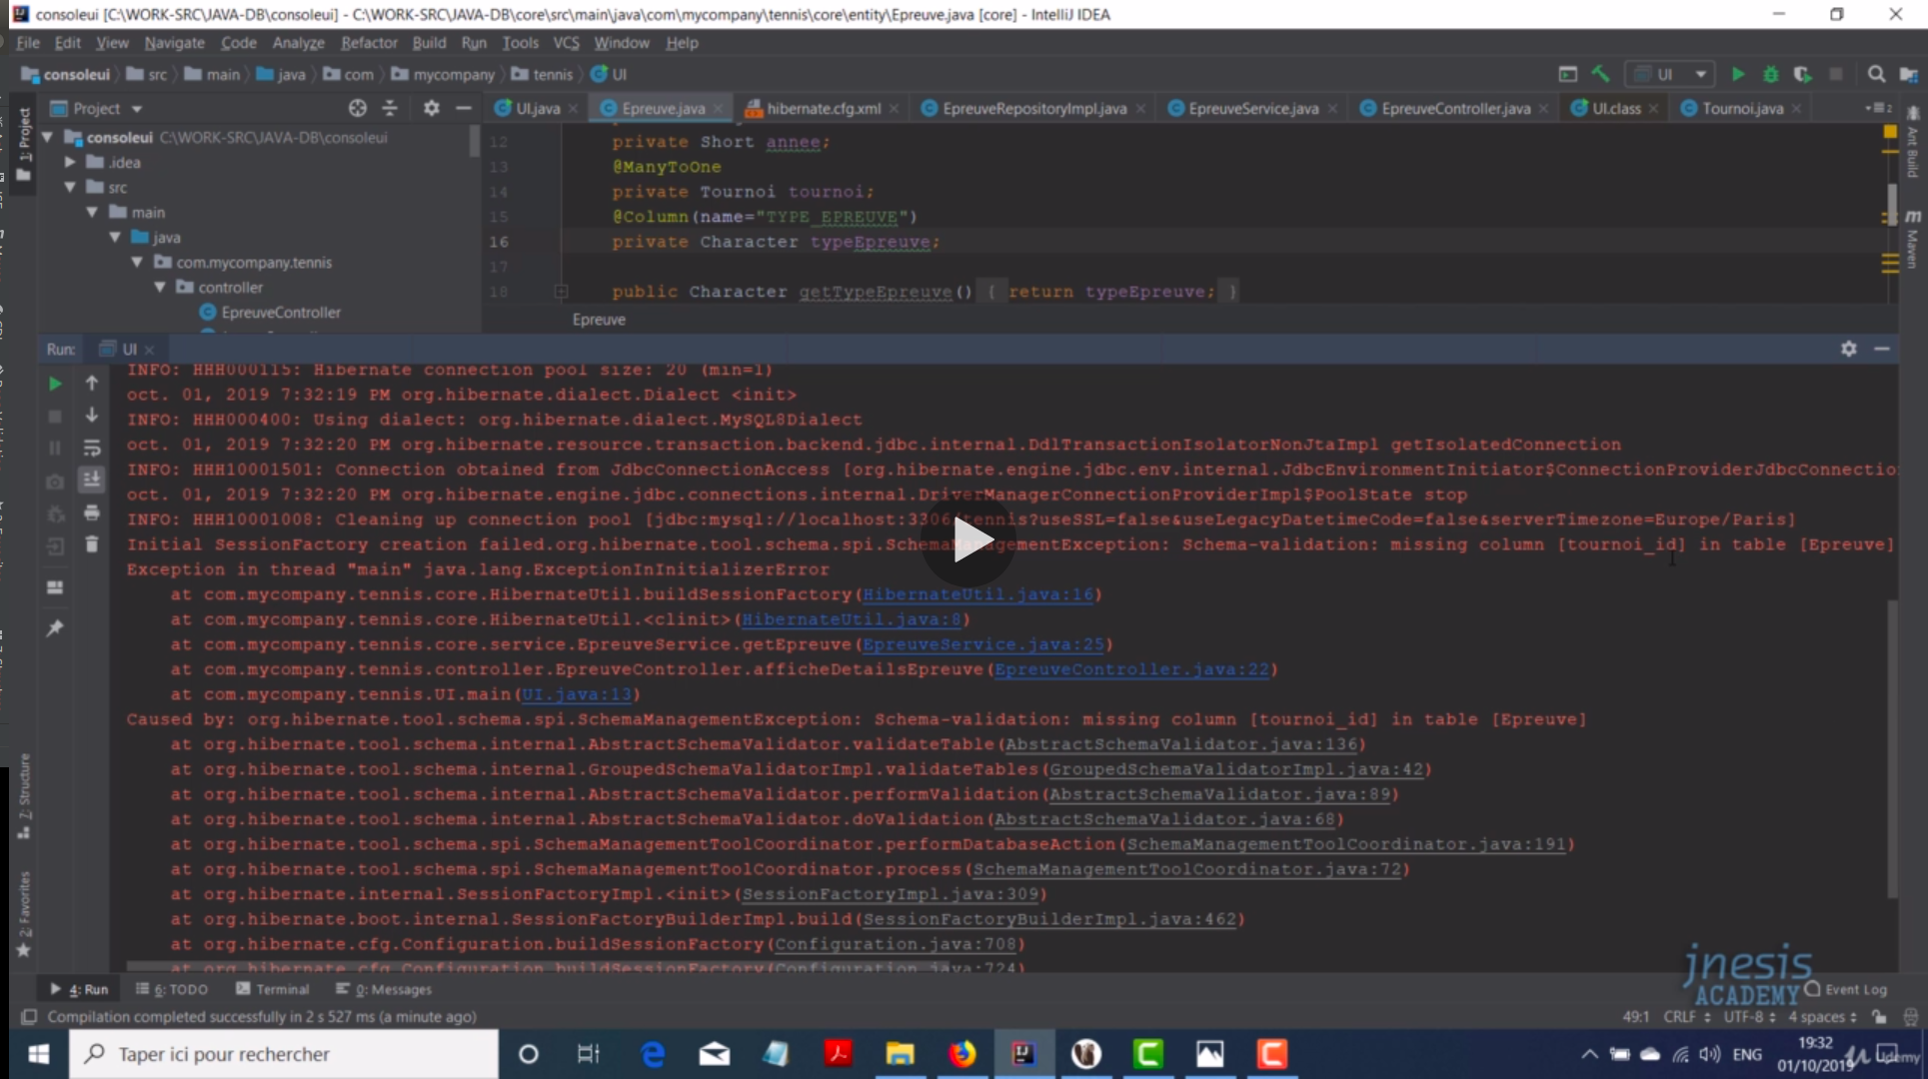

Causa: El nombre del campo clave foraneo, no se encuentra definido en tabla identidad
arreglamos con anotacion: @JointColumn(name = "ID_TABLA")
Hibernate Automaticamente Toma el Nombre la tabla adicionar y le concatena tournoir_id.
Buena practica de considerar en Modelo relacional de BD.

Funcionamiento normal de Hibernate
